FOR IMMEDIATE RELEASE

THE SURREAL WORLD OF THE TWIXT COMES ALIVE AGAIN IN

INVISIBLE
By Dawn Metcalf
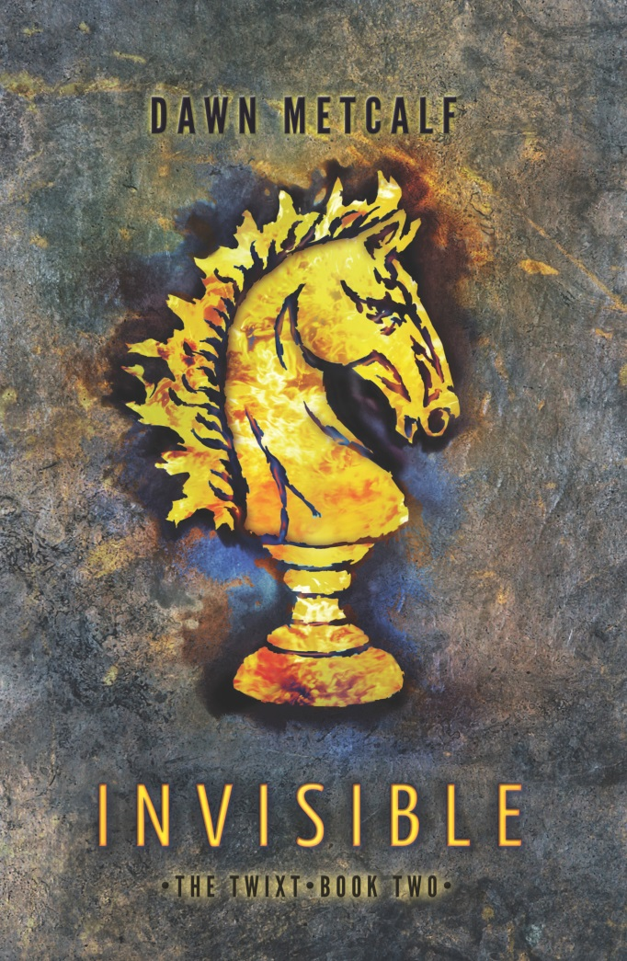
“Fans of fae fantasy, YA paranormal and modern fantasy will all adore this novel and find themselves willingly trapped within the Twixt. Read. This. Book!” —USA Today’s Happy Ever After blog on INDELIBLE

Join heroine Joy Malone as she ventures deeper into The Twixt universe with the much-anticipated second novel, INVISIBLE (Harlequin TEEN, September 2014, $9.99 U.S./11.99 CAN.). Joy never could have predicted the intense bond that would grow between her and the mysterious creature known as Indelible Ink, but she has come to love him and will let nothing stop her from making a place for herself in his world. Now Joy’s newfound ability to undo the marks that invisibly bond humans and supernatural folk makes her a target. Pursued by a relentless assassin, Joy must fight to protect herself—and her beloved Indelible Ink.

INVISIBLE delivers an unforgettable adventure, exploring universal themes of self-identity and coming of age, and tracing a passionate and growing love story. INVISIBLE is available wherever books are sold and at Harlequin.com.

INVISIBLE
DAWN METCALF
$9.99 U.S./$11.99 CAN.
ISBN: 978-0-373-21107-4

Dawn Metcalf
Dawn Metcalf writes about fairy tales, myths, and sharp, pointy objects. She has yet to be whisked away to Fairyland, but also has yet to be stabbed in the eye. You can find her and her family buried somewhere beneath piles of costuming, crayons, karate pads, board games and other assorted mayhem masquerading as a normal Victorian house in northern Connecticut. If they had a sign, it would read: Confounding the Neighbor Children Since 1999. For more information on Dawn and the Twixt, visit www.dawnmetcalf.com.

