

FOR IMMEDIATE RELEASE Contact: Lisa Wray
lisa_wray@harlequin.ca
(416) 445-5860

FANTASY AUTHOR DAWN METCALF KNOWS THAT

SOMEWHERE BETWEEN REALITY AND MYTH

LIES THE TWIXT

INDELIBLE

August 2013

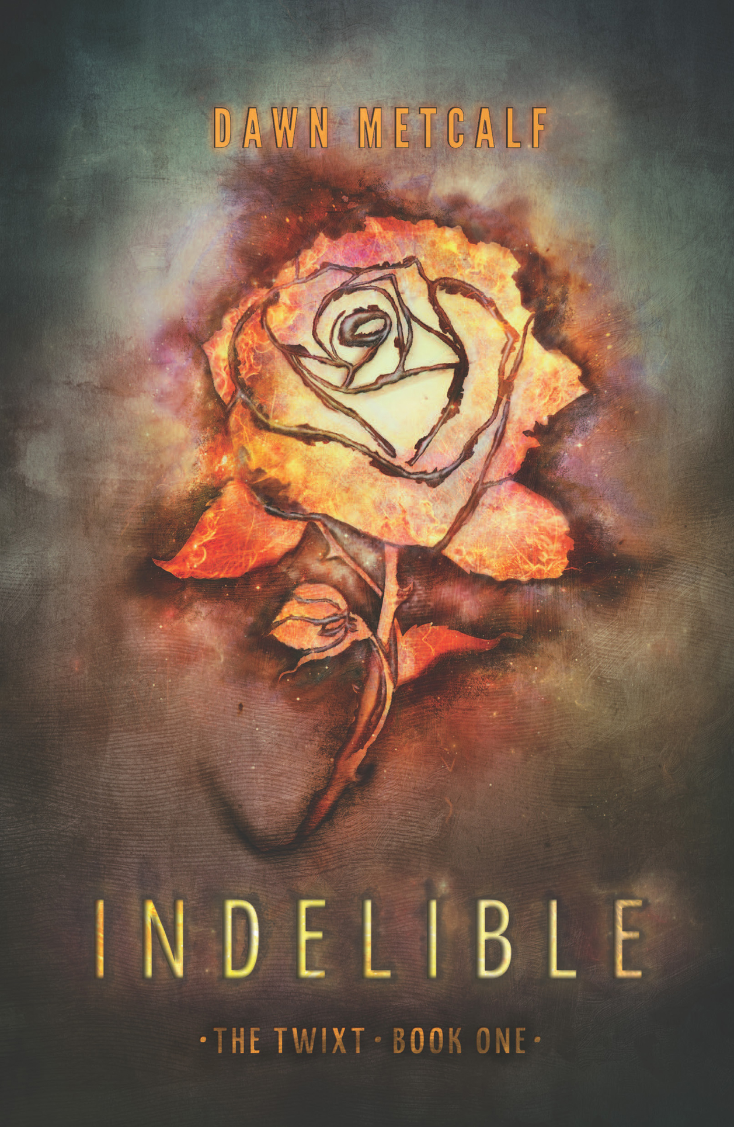
A young girl’s life is forever changed when she is marked by a mysterious fae boy and drawn into the fantastical and dangerous world of the Twixt in INDELIBLE (Harlequin Teen, August 2013, $9.99 U.S./$11.99 CAN.), the first book in the stunningly powerful The Twixt fantasy series by Dawn Metcalf.

Some things are permanent. Indelible. And they cannot be changed back. Joy Malone learns this the night she sees a stranger with

all-black eyes across a crowded room—right before the mystery boy tries to cut out her eye.

Instead, the wound accidentally marks her as property of Indelible Ink, and this dangerous mistake thrusts Joy into an incomprehensible world—a world of monsters at the window, glowing girls on the doorstep and a life that will never be the same.

Now Joy must pretend to be Ink’s chosen one—his helper, his love, his something for the foreseeable future and failure to be convincing means a painful death for them both. Swept into a world of monsters, illusion, immortal honor and revenge, Joy discovers that sometimes there are no mistakes.

Metcalf’s unique style and distinct voice add layers to a complex plot and create a fascinating romance that readers will find unforgettable.

INDELIBLE will be available wherever books are sold and at Harlequin.com.

INDELIBLE

DAWN METCALF
$9.99 U.S./$11.99 CAN.
ISBN-13: 978-0-373-21073-2

Dawn Metcalf

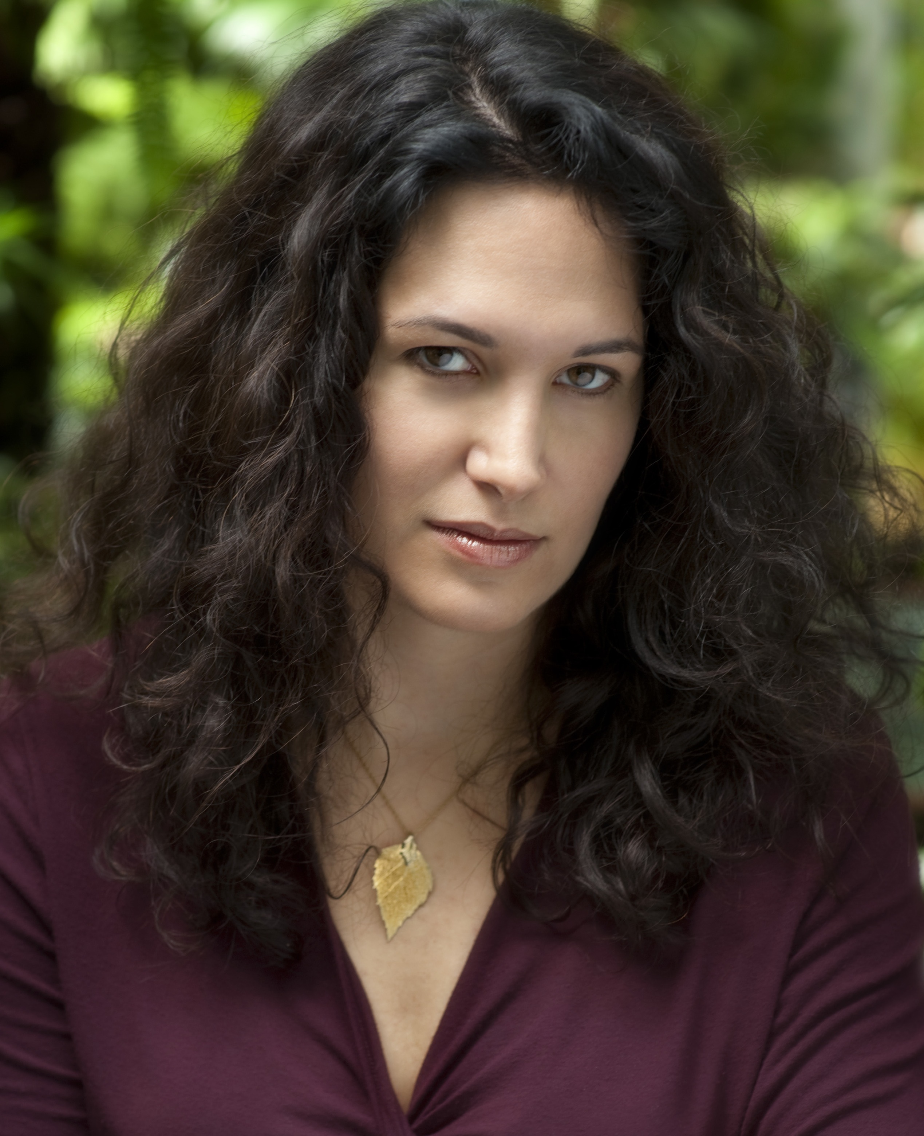
The role of Dawn Metcalf will be played by the tall brunette in the off-the-shoulder, floor-length leather straitjacket. Makeup by Clinique, buckles by Jada Pinkett Smith, hair by Jim Henson’s Creature Shop.
I have no good excuse for the way I write. I lived in a normal, loving suburban home, studied hard, went to college, went to graduate school, got married, had babies and settled down in northern Connecticut. Despite this wholesome lifestyle, I’ve been clearly corrupted by fairy tales, puppet visionaries, British humor and graphic novels. As a result, I write dark, quirky and sometimes humorous speculative fiction.
.

